Healthcare Domain Meeting:  August 21, 2020 9 am-10:30am  Via Zoom | Next Healthcare Domain Meeting:  September 18, 2020 9am-10:30am  Via Zoom
Attendees: Kathryn Goldberg, Kussy Mackenzie, Blanca Melendrez, Cheryl Moder, Miranda Westfall, Suzanne Afflalo, Mary Beth Moran, Shannon Jackson, Kim Elkins, Carissa Hwu
Recorder: Carissa Hwu

Topic/Issue | Discussion | Action
Welcome/Introductions | Mary Beth led introductions.  Kathryn moved to approve last meeting’s minutes.  Blanca seconded that motion.  Meeting minutes approved.
Cheryl Moder, San Diego Accountable Community for Health | Be There San Diego  - Much more clinically focused than the SD Healthcare Quality Collaborative  - Coalition of patients, communities, healthcare systems and others working together to prevent heart attacks and strokes  - Established in 2010 as clinical learning collaborative to heart attacks and strokes with UCSD as fiscal lead  - Shared data and best practices  - Reach project from the CDC: project working to reduce blood pressure in Black communities through connecting with religious community leaders  SD Healthcare Quality Collaborative is a nonprofit organization  - Established in 2016 to support upstream, multi-sector efforts to advance health and wellbeing with a focus on equity  - Includes San Diego Accountable Community for Health, Neighborhood Networks  Current Initiatives  - All span the spectrum of prevention: downstream, midstream, and upstream  - Accountable Community for Health is more upstream and midstream (improve community conditions and addressing individuals’ social needs)  - Neighborhood Networks is midstream (addressing individuals’ socials needs)  - Be There SD is downstream (providing clinical care)  SD Accountable Communities for Health Initiative  - Part of a statewide initiative that was established 4 years ago  - State applied for funding to create this organization, but did not receive it  - Private foundations and funders came together to pool their resources and fund/invest in this organization  - Blue Shield of CA  - California Endowment  - Sierra Health Foundation  - Kaiser Permanente  - Community Partners  - CHHS  - Each community is encouraged to select its own health issue (range from asthma to CVD to violence reduction). But, there are shared pillars/goals for all ACHs  - Shared vision and goals  - Governance (partners and leadership)  - Strong community resident engagement  - Backbone organization  - Data analytics and sharing capacity  - Wellness fund and sustainability  - Portfolio of interventions  - Mission: to create a “wellness system” that ensures individuals, families, communities in SD have access to all they need to create a lifetime of health and wellness  - Vision: health, wellness, and equity for all communities – regardless of zip code  - Values: equity, inclusivity, neutrality, accountability  - First aim: achieving ideal cardiovascular health across the lifespan  - Understand that there are multiple causes of CVD and multiple solutions  - Focused on PSE change and also invested in community interventions  - Governance Structure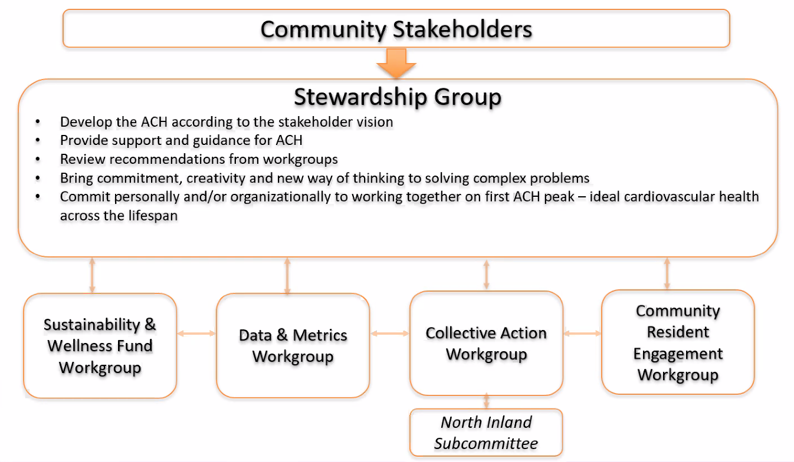  - 2020 Initiatives  - Neighborhood Networks:  - Directly addressing health impacts of SDOH and root causes of poor health outcomes  - Creating financial sustainability (Wellness Fund) to support SD ACH backbone and (in the future) community interventions  - Collective Action Framework  - Creating new clinical-community linkages  - Enhancing interventions through mutual reinforcement and systems change  - Sharing performance data  - Creating a model for POI replication for other regions and/or protective factors  - Stakeholder Action Community  - Connecting multi-sector partners  - Building partner capacity through training and workshops, etc.  - Enhancing equity and inclusivity  - Encouraging advocacy  - Supporting learning and innovation  - CVD Protective Factors, centered around Equity and Access  - Manage blood pressure  - Control cholesterol  - Increase physical activity  - Improve nutrition  - Maintain healthy weight  - Quit smoking  - Improve well-being (includes well-being of communities)  - Control blood sugar  - Portfolio of interventions  - Network of solutions (e.g., programs, interventions, community resources, assets) designed to reinforce each other for greater impact  - Designed to achieve community health and wellness goals  - Created by a cross-sector collaborative of community partners  - Should be balanced across:  - Spectrum of prevention: clinical, community, clinical-community linkages, PSE  - Protective factors  - Geographic regions, ages, incomes, populations, health outcomes, etc.  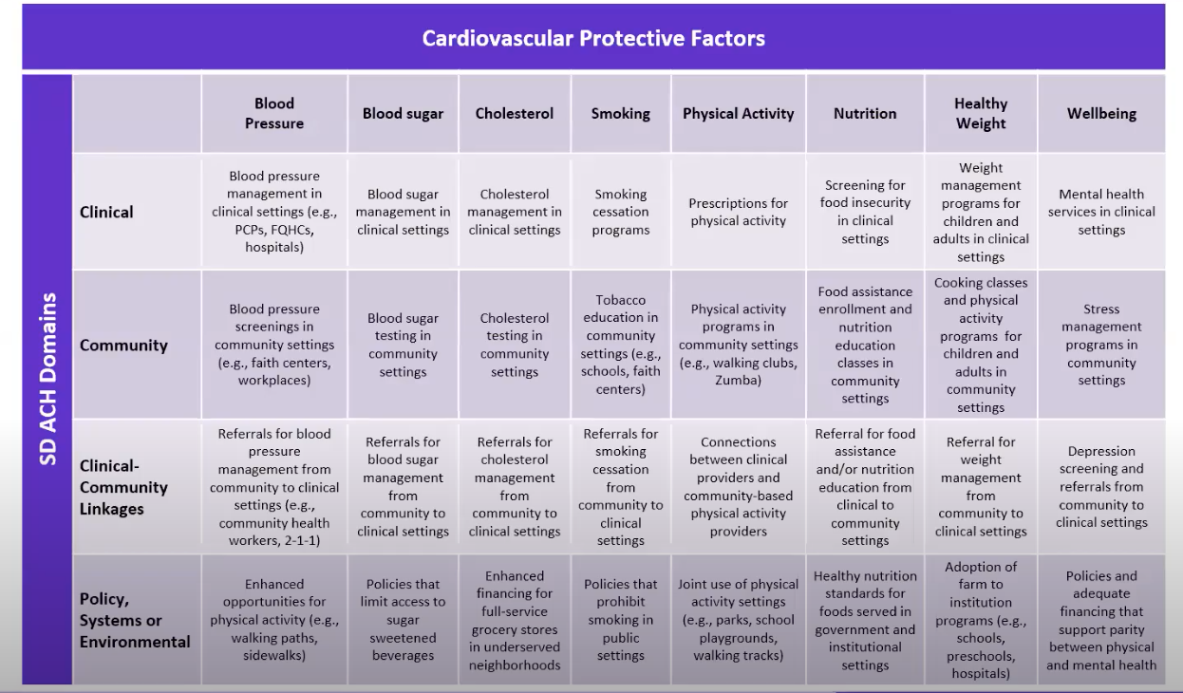  - Example of “Ideal” POI in SD County  - Addressing all factors across the entire community  - Very daunting task  - Wanted to start with a more focused approach geographically and with only 1 protective factor  - North Inland Region POI Pilot  - North Inland is one of the largest regions in SD County  - Region selected by SD ACH Collective Action Workgroup  - Convened subcommittee in early 2019  - Selected nutrition/nutrition security as protective factor  - Multiple sectors represented: healthcare, nutrition assistance organizations, HHSA, 2-1-1 SD, nonprofit organization  - Wanted to create a model that could be replicated in other regions  - Results-Based Accountability Process  - Data-drive, step-by-step approach  - What are our goals and indicators?  - Define goal  - Determine 3-5 relevant nutrition indicators  - How are we doing?  - Review baseline and trend data for the selected nutrition indicators  - Determine what will happen if we do nothing  - What is the story behind the curve?  - Identify North Inland landscape, underlying conditions, root causes, political and/or institutional environments  - Which partners play a role?  - Review identified partners  - Identify existing relationships between/among partners  - Determine who else needs to be at the table  - What is working?  - Review best, promising, innovative, and low-, no-cost practices  - Identify what is working in the community  - What is our action plan?  - Determine strategies and activities for each indicator  - Bring partners together  - Identify opportunities for alignment, enhancing strengths, and/or addressing gaps  - Performance accountability  - Obtain program data from identified interventions  - Analyze results  - Track and monitor progress  - Assess progress toward indicators  - Broad Goal: all people in North Inland Region eat sufficient quantities of nutritious foods  - Utilize trauma-informed approach  - Addressing quality and quantity of food in a way that is respectful  - Indicator 1: Food insecurity in North Inland compared to SD  - Indicator 2: Children who eat adequate amount of fruits and vegetables in North Inland compared to SD  - Story Behind the Curve – Barriers  - Current political climate  - Perceived higher costs of nutritious foods  - “Food deserts” due to built environment and/or transportation issues  - Less time to prepare nutritious meals  - Less food access and funding in rural areas  - High cost of housing and other basic needs  - Highly affected populations: rural residents, migrant farm workers, those living on reservations  - Large ICE presence  - Fear of public charge rule  - Story Behind the Curve – Assets  - Expanded SD Food Bank in San Marcos  - Hospitals and clinics conducting nutrition security assessments  - 2-1-1 and CIE conducting SDoH screenings  - Indian Health Council provides resources and has access to federal funds  - Escondido’s mayor is supportive of nutrition security efforts  - Which Partners Play a Role  - Over 50 programs identified that serve North Inland region with nutrition services that address selected indicators  - Criteria for POI inclusion:  - Open to working with others toward shared goal and indicators  - Open to partnering with other to enhance opportunities for program improvement  - History of working well with others  - Willing and able to make time commitment  - Willing to share program data in aggregate form  - Programs categorized to determine balance across ACH domains and health equity lenses  - Subcommittee members serve as leads for all strategies and objectives  - One organization has been identified that could possible serve as “mini backbone” to carry work forward  - What is Working  - Conducted literature review to determine evidence-based, promising, and innovative nutrition practices  - Explored ways for interventions to employ equitable, effective methods  - Strategies and Objectives  - Increasing number of organizations that serve children ages 2-5 that do standardized nutrition security screenings and make appropriate referrals  - Focus on home visiting programs and early care and education providers to implement two-question validated nutrition security measurement tool  - Led by Nancy Roy, community advocate  - Increase number of schools that implement practices that increase access to and consumption of nutritious foods  - Create a learning collaborative for North Inland region school district nutrition services directors  - Lead: Candy Gibson, North County Food Policy Council  - Increase participation in distribution of fresh foods by food pantries and congregate meal programs  - Increase North Inland region participation in SD Food Bank’s Feeding Everyone with Equity and Dignity (FEED) program  - Lead: Shelley Parks, SD Food Bank  - Increase trauma-informed nutrition policies and programs  - Conduct Trauma-informed Nutrition Learning Collaborative  - Next Steps:  - Determine performance measures for each objective  - Engage additional partners  - Implementation  - Ongoing measurement and reporting using public-facing scorecard  - Documentation of process for implementation in other geographic regions and/or for other protective factors  - ACEs Activities  - ACEs Aware: state-funded training and reimbursement to Medi-Cal providers for ACEs screenings  - Supports training and engagement of a wide range of providers and encourages collaboration among organizations to build networks of care  - Funded activities include: core/supplemental provider trainings, provider engagement activities, communications  - ACEs Aware Contract  - Conduct provider engagement activities with a focus on building clinical-community linkages  - 4 2-hour “network of care” sessions  - White papers: role of ACH’s in addressing ACEs, role of CIE in assessing/addressing ACEs  - 12-month grant period beginning July 2020  - Other local funded organizations: American Academy of Pediatrics Chapter 3, SDSU Social Policy Institute, YMCA  - Live Well SD Partnership  - Obtain input from youth-serving organizations  - Create a feasibility plan for meaningful adoption of Trauma-informed Care Code of Conduct principles  Neighborhood Networks  - Designed to address at-risk individual health/social needs using a network of community-based solutions with highly trained Neighborhood Navigators at the center  - Community Health Worker model  - Unique components of NN:  - Highly-trained, cultural competent Neighborhood Navigators from the communities they serve  - Navigators employed by trusted community-based organizations  - Operations and administration managed through a central and local HUB  - HUB at the Center  - Effectively links referred clients to community-based organizations and provides management services  - Contracts on the referral side with health plans  - Reimbursement, referrals, data sharing, training  - Identify and Address Comprehensive Risks Across 4 Domains  - Health Navigator conducts very in-depth health assessment with client to identify social, medical, behavioral health, and safety risks  - One Coordinated Solution  - Coordinated approach to support clients in all their risk factors  - Central source of referrals  - Example: connecting client to primary care, food assistance programs, mental health provider, arrange transportation to all appointments  - Neighborhood Navigators  - Are based in communities served  - Build on trusted relationships  - Identify and address unmet health-related social needs  - Connect clients with local resources  - Provide follow-up  - Track outcomes in centralized system  - Provide feedback to health plan  - Community-based Organizations  - Exhibit community competency  - Understand local social determinants of health  - Have deep, trusted community partnerships  - Are building a workforce of residents with lived experience  - Standardized Practices  - Assess Risk  - Utilize Evidence Based pathways  - Track and Measure  - Current Contracts  - HealthNet, Molina, Community Health group  - 3 Community Care Organizations  - 7 Neighborhood navigators  - Over 100 clients enrolled since January 2020  Questions/Discussion  - How do people get referred into Neighborhood Networks program?  - Working on possibilities for this: referrals from ACEs screening, doing outreach with certain providers who have a lot of Medi-Cal clients  - Who does the recruitment and training of Neighborhood Navigators?  - Navigators hired by community-based organizations (SAY SD, Chula Vista Community Collaborative, North County Lifeline)  - Training is conducted by SD ACH to ensure that there is consistency and in-depth training  - Initial training and ongoing training  - Where does the refugee population land in all of this? Are we making sure to hire culturally sensitive navigators who speak languages among refugee communities?  - SAY SD in Central Region and South  - One of the guidelines for CCOs include hiring people with lived experiences from the communities being served  - All Neighborhood Navigators currently speak English and Spanish, but working to expand this  - Discussing how to engage other CCOs to bring in more Neighborhood Navigators from different communities who speak more languages  - Potentially pitch a Provider Workshop on trauma-informed nutrition for parents and children and referrals. Any recommendations for a presenter? And do you think this would be a useful workshop?  - American Academy of Pediatrics is going to be doing a supplemental training for providers, peer-to-peer (among clinicians/pediatric providers). Can connect co-chairs of this domain with someone from AAP.  - YMCA is working on toolkit for physicians on ACEs, definitely room there to make connections.  - Is there an anti-racism training that’s facilitated by the HUB? Training for the physicians?  - Not sure if anti-racism training is included in the broader plan for ongoing training. Will check to see.  - What’s being put in place for the CCOs to take over the work in place for the HUB after the funding is gone?  - The plan is for the HUB to maintain its role in an ongoing manner. The contracts with the health plans will continue to support/fund the HUB and the CCOs  - Not grant funding  - Projected revenues to support ACH, the HUB, and future CCOs involved  - For Neighborhood Networks, are you using any tech platforms for referral management?  - Blue Shield does not require us to utilize their platform. We do not use any platform other than our case management program, which tracks referrals. Also in the process of talking with CIE. Encouraging all CCOs to become CIE partners. They are all either in the process of doing so or already partners. Longer term plan is to utilize CIE as much as possible to do the best job possible for client referrals.  - There has been a lot of discussion around addressing systemic racism as one of the root causes of ACEs  Contact Cheryl Moder at cheryl@modercommunications.com or 619-878-2006 for more information.
COI and Partner Updates | COI Updates  - Will share Advocacy updates next month  - We will be promoting Black Breastfeeding Week through social media (August 25-31)  - 2 approved posts that will be sent through email  - From here on out, COI will pick 1 week every month to ask participating partners to post consistent messaging across all social media platforms to get consistent messaging/resources/information out to communities. We will send out 2 posts that can be copied and posted or tweaked to tailor to organization’s branding.  The SHARC-Scripps Town Hall recordings on COVID-19  - First town hall (August 5): https://youtu.be/5aAFs5Bbf9E  - Second town hall (August 11): https://youtu.be/gQW85obapis
Next Meeting | The next meeting will take place on September 18 from 9:00 AM – 10:30 AM.

